INVESTIGATING BMF-CreERᵗ² IN NEURAL DEVELOPMENT
OF AXONAL PRUNING

A Capstone Project
Presented to the
Faculty and Staff of
Riverside STEM Academy High School

In Partial Fulfillment
of the Requirements for the Scholar’s Diploma

By
Norah Pham

Approved by: Catherine Murray

Project Advisor: Catherine Murray and Apryl West
Project Mentors: Dr. Martin Riccomagno and Teresa Ubina
Principal: Jeremy Standerfer
2024

ABSTRACT
Studies show that disrupted neural pathway organization, also known as pruning anomalies, could be linked to conditions like schizophrenia or autism. Studies with schizophrenia are consistent with the conclusion that there are fewer synaptic connections in the postmortem brains of these patients, however, they do not inform us about “synaptic changes during the onset of symptoms in young adulthood where the bulk of pruning occurs” (Boksa, 2012). Furthermore, excessive cortical pruning during puberty is strongly correlated with the early onset of schizophrenia (Lewis & Levitt, 2002). It's clear anomalies in pruning events during adolescence are likely at the root of certain neural disorders. Pruning is difficult to study because evidence of it is only present for a brief time. One well-characterized pruning event is in retinal ganglion cells. Previous data from our lab shows that the Bcl2 modifying factor (Bmf) is highly expressed in the retina just before the retinal ganglion pruning event. My project aims to investigate if a genetically engineered mouse line, Bmf-CreERT2, can effectively label these pruning events to better study the molecular mechanisms behind pruning. When the Bmf-CreERT2 mice are crossed with the Cre reporter line, Ai14, we can permanently label any cells that are expressing Bmf with a red fluorescent protein (tdTomato). To ensure this mouse line can properly label pruning events, I treated four different age groups postnatal days 2-4, 10-12, 15-17, and adults with tamoxifen or corn oil. When Bmf-CreERT2 mice are crossed with the Cre reporter line, Ai14, cells expressing Bmf are permanently labeled with a red fluorescent protein (tdTomato). To validate this mouse line, four different age groups (postnatal days 2-4, 10-12, 15-17, and adult) were treated with tamoxifen or corn oil. Results indicate an average count of 11.99% positive labeling at postnatal days 2-4, aligning with a known pruning event and confirming the mouse line's ability to label the right cells at the right time. Between postnatal days 15-17 and adulthood, pruning decreases significantly, reaching 0%, affirming the mouse line's capability to label the pruning event occurring from age P2-4 effectively. These findings validate the Bmf-CreERT2 mouse line, enabling its continued use for further research. Future investigations will extend beyond retinal ganglion cells, exploring different brain areas labeled during development to uncover potentially unknown pruning events.

Table of Contents
ABSTRACT… 2
ACKNOWLEDGEMENTS… 4
FIGURES… 5
Chapter
- REVIEW OF LITERATURE… 6
Introduction…
History….
Technology…
Next Steps….
Conclusion…
- METHODOLOGY 13
Rationale…
Comprehending the Steps of Gene-Editing…
Science Fair Experiment…
Middle School Lesson…
- FINDING AND DATA ANALYSIS 20
Recording and Analyzing Data …
Overall Analysis…
- CONCLUSION 25
- BIBLIOGRAPHY 27

ACKNOWLEDGEMENTS

This Capstone project would not have been possible without the guidance of the staff at Riverside STEM High School and the kind and diligent scientists at UCR’s Riccomagno Lab, I would like to extend my gratitude in particular to the following people:

Mrs. Catherine Murray and Ms. Apryl West, for being a guiding light in helping cultivate my project from start to finish. You guys were a great source of feedback, a bouncing point for exciting ideas that characterize this project.

Mr. Eric Mayhew, for helping assist in printing out my poster boards, and providing me with helpful feedback in my lesson with the 8th Graders.

Professor Martin Riccomagno, for providing me the opportunity to volunteer in his neurodevelopmental laboratory at UC Riverside.

I extend my gratitude to graduate student Teresa Ubina, whose unwavering guidance, expert knowledge of lab procedures, and steadfast support have been invaluable throughout this project. Lastly, I would like to express my appreciation to graduate student Alyssa Treptow for her assistance in helping me analyze slides.

LIST OF FIGURES
Figure Page
- Diagram of Gene Editing… 15
- TdTomato Expression Diagram… 16
- Table of Tested Mice with Age and Treatment… 17
- Fiji Module to Cell Count 20
- Data Table with Results on Mice… 21
- Pivot Table Analyzed Data… 22
- Organized Imaged Coded Data of Results… 23
- Bar Graph Data Reflection 24

CHAPTER 1
REVIEW OF LITERATURE

Introduction
Evolution is defined as the changing of an organism over time; with all change, there is a purpose to create a more efficient, viable life. Embedded within the fabric of evolutionary history is synaptic pruning, a subtle yet profound mechanism that fine-tunes the neural architecture of living organisms: allowing us to think, feel, move, and apprehend skills more efficiently. One of the grand strategies nature uses to construct nervous systems is to overproduce neural elements, such as neurons, axons, and synapses, and then prune the excess. The overproduction is substantial enough that only about half of the neurons mammalian embryos generate will survive until birth (Feiberg, 2017). Synaptic pruning has garnered significant attention in neuroscience research due to its implications for neurodevelopmental disorders when an excessive or insufficient amount of synaptic pruning occurs. Studies with schizophrenia are consistent with the conclusion that there are fewer synaptic connections in the postmortem brains of these patients, however, they do not inform us about “synaptic changes during the onset of symptoms in young adulthood where the bulk of pruning occurs” (Boksa, 2012). Furthermore, excessive cortical pruning during puberty is strongly correlated with the early onset of schizophrenia (Lewis & Levitt 2002). Multiple studies like these have shed light on the intricate molecular mechanisms underlying synaptic pruning and its dysregulation in pathological conditions, prompting the exploration of novel research avenues to understand its role in multiple neurodevelopmental disorders.

History
For years, neuroscientists held the belief that neural pruning ceased shortly after birth. However, in 1979, Peter Huttenlocher, a neurologist from the University of Chicago, overturned this notion by revealing through electron microscopy analysis of autopsied human brains that excess synapse production and pruning continue long after birth. Huttenlocher's work demonstrated that synapses, the connections between neurons, proliferate postnatally, doubling in number by mid-to-late childhood before declining sharply during adolescence (Walsh., 2006). These synaptic changes drive neural restructuring, likely impacting both normal and abnormal brain function significantly.
Neural restructuring is also synonymous with neuroplasticity. This refers to the brain's ability to adapt and change by forming new connections between neurons, reorganizing existing ones, and potentially even generating new neurons. Mechanisms of neuroplasticity are highly variable across individuals and throughout the lifespan. They are influenced by factors such as inhibitory network function, neuromodulator systems, age, sex, brain disease, and psychological traits. The term was coined by Jerzy Konorski in the mid-20th century. However, through the support of scientists in the 1940s like Eugenio Tanzi, he was able to come to these conclusions. Tanzo identified the junctions between neurons, which we now call synapses, as potential sites of where neural refining (now known as neuroplasticity) occurs (Buchtel, 1978). He recognized that changes at these synapses could underlie the adaptive changes observed in the nervous system in response to experiences.
Under a research paper called Dynamic Brains and the Changing Rules of Neuroplasticity: Implications for Learning and Recovery years later, it was revealed sensory experiences shape cortical plasticity during critical periods (CPs), emphasizing that CPs can also be reopened later in life due to various factors (Voss et al., 2017). Connecting the understanding of neuroplasticity, synaptic pruning was identified to be a one-way reorganization that could occur in the brain: by way of eliminating extra neurons and synapses (Cherry et al., 2022).
As pruning has been connected to different phenomenons, it was found the “refinement of neural circuits during adolescence can explain why young adults often experience a boost in cognitive skills” and the avoidance of rash decisions as they grow up (Hartley et al., 2015). On the other hand, the reduction in redundant pathways could hinder recovery from traumatic brain injuries, as it limits the “brain's capacity to develop alternative routes to bypass damaged areas.” (Hylin et al. 2017).
The onset of many major mental illnesses during adolescence suggests a potential link to abnormal synaptic pruning. In the 1980s, it was hypothesized that disrupted synaptic pruning might explain the onset of schizophrenia, a theory supported by genetic and experimental findings (Feinberg., 1982). Research four decades later examined changes in certain proteins and their levels in the brains of schizophrenic patients. These specific proteins are involved in communication between brain cells. A Meta-Analysis and systematic review of Synaptic Protein and mRnA by Osimo, E.F. et.al (2018) revealed lower levels of a protein called synaptophysin in specific brain areas of those with schizophrenia. Synaptophysin is a protein found in membranes of synaptic vesicles that store and release neurotransmitters. The presynaptic terminals of neurons have been extensively researched by scientists which has led to it being a reliable indicator to measure the density of neuronal synapses and the number of synapses. The lower levels of the protein suggest a loss of connections between cells in these regions, this has led to hypotheses that a loss of connections could be due to neural pruning (Osimo et al., 2018).
Continuing the exploration of schizophrenia to pruning, scientists found that alterations in “synaptic density, dendritic spine density, and presynaptic protein markers have been observed in postmortem brains of adult schizophrenic patients.” (Boksa, 2022). Thus suggesting additional abnormalities in synaptic connectivity. Moreover, neuroimaging studies have revealed enhanced synaptic pruning during the early stages of schizophrenia, coinciding with gray matter loss and cognitive deficits, further implicating abnormal synaptic remodeling (pruning) in the disease progression (Boksa, 2022).
In the realm of autism research, the under-pruning hypothesis proposed by Tang et al., (2014) suggests that reduced synaptic trimming during early development may contribute to the pathogenesis of autism spectrum disorders. Several genes associated with autism spectrum disorder (ASD) affect pathways in brain cells that connect at certain points called glutamatergic synapses (Bourgeron, 2009; Peça and Feng, 2012). This suggests that issues with dendritic spines might play a role in ASD. In ASD brains, there are more of these dendritic spines located in the “frontal, temporal, and parietal lobes of the brain” (Hutsler and Zhang, 2010). This was also evident in brain cells seen in mice with ASD-like traits (Zoghbi and Bear, 2012). These conclusions align with research on humans, as children with autism have about sixteen percent synaptic pruning, compared with children without autism, who have roughly half (Columbia., 14). Children with autism lack a degradation pathway called autophagy. In this process, cells break down and recycle their own components, such as damaged organelles or proteins, to maintain proper function and respond to stress or nutrient deprivation. Instead, those with autism fill their cells with old and damaged components (Tang et al., 2014). Researchers have also found that ASD children show a temporary decrease in a type of brain cell called microglia which has shown problems with pruning connections between neurons (Zhan et al., 2014).

Technology
Neurons have multiple ways to deal with cell damage or refine neural connections, but the two most prominent ways are apoptosis (cell destruction) and axon degeneration (pruning). Both processes involve proteins including Bax and caspases. Axon degeneration during apoptosis is different from axon pruning. Caspase-6 activates in axons when there's a lack of nerve growth factor (NGF), but it only protects axons in specific situations, not during whole-cell apoptosis. Axon-selective degeneration requires Caspase-9 and Caspase-3, which are not needed for apoptosis. The significance of understanding pruning is the fact that pruning is selective apoptosis. This is where only part of a cell is removed. Mechanisms like proteasome activity and the X-linked inhibitor of apoptosis protein protect cell bodies of degenerating axons from caspase-6 activation, thus allowing for only certain parts of the cell to be removed (Cusack et al., 2014). Furthermore, because mature neurons can prevent apoptosis while still allowing axon degeneration, this shows independent regulation (Pemberton et al., 2020). These findings reveal how neurons control both apoptosis and axon-selective degeneration to adapt without risking neurodegeneration.
Experimental studies utilizing animal models have provided valuable insights into the molecular mechanisms governing synaptic pruning. One way to track cell survival following caspase-3 activation during development in vivo is via CasExpress (Ding et al., 2016). This specific research article discovered that caspase-3 carries out the executioner phase of apoptosis, however under special circumstances, cells can survive its activity. The casExpress system in vivo opens the door as a tool to study when caspase-3 activation occurs. However, only in drosophila flies does this system work.

Next Steps
The development of genetically modified mouse lines offers promising opportunities for investigating synaptic pruning events with high precision, such as the BMF-CreERT2 line. Inspired by CasExpress, the transgenic mouse line could mirror CasExpress capabilities on a wider scale; specifically to an organism that has a closer genetic profile to humans. The system, instead of focusing on caspase-3, mainly identifies when BMF is upregulated. Bmf is a “pro-apoptotic BH3-only protein,” meaning it plays a large role in controlling when apoptosis occurs. Akhter et al. (2018) investigated the role of the pro-apoptotic protein BMF in mediating neuron death induced by nerve growth factor (NGF) deprivation; a protein that is involved in Alzheimer's disease. The study demonstrated that Bmf, along with other BH3-only proteins, plays a critical role in apoptotic pathways. Thus revealing a connection with Alzheimer's disease and BMF’s potential involvement in synaptic pruning. By employing strategic genetic engineering like that of the BMF-CreERT2 line, researchers can label and track pruning events in specific cell populations by monitoring the levels of BMF. Additionally, can gather data on when pruning occurs in the brain. This approach offers valuable insights into synaptic remodeling.
The use of CRISPR Cas-9 can allow for a specific piece of DNA to be added to a gene’s coding sequence. At the UC Riverside Molecular Biology Neurodevelopmental Dept., a transgenic mouse line was created to identify when BMF is upregulated by the use of a fluorescent protein that glows when activated. Although pruning is a known phenomenon, there is limited research on the molecular players involved. Currently, tools that can track pruning can only detect these events for a short window of time or are limited to only certain kinds of organisms, like drosophila flies. With the genetically engineered mice line, researchers would be able to identify the exact time pruning occurred, allowing for a more accurate scope of study behind the molecular players involved in the process later on.

Conclusion
Pioneering research by Peter Huttenlocher has revolutionized our understanding, revealing synaptic pruning's continued postnatal occurrence and its connection to neuroplasticity. Insights from Osimo et. al (2018) and Boksa (2022) highlight synaptic pruning abnormalities as potential contributors to Alzheimer's and ASD. The research by Ding et al. (2016) and Akhter et al. (2018) exemplify the innovative approaches employed to unravel the molecular mechanisms underlying synaptic pruning and its role in neurodevelopmental disorders. This includes advancements in technology, like genetically modified mouse lines and CRISPR Cas-9 technology. By leveraging innovative research tools and animal models, scientists aim to unravel the complex molecular mechanisms underlying synaptic pruning and its contribution to disease pathology.

CHAPTER 2
METHODOLOGY

I began reviewing gene-editing technologies, extensively on CRISPR-CAS9, including understanding the specific genes that alterations would occur in, the delivery methods of the proteins, and past models of transgenic mouse lines. Once the mice line was created, it was bred to create the line termed BMF. Additionally, lab safety precautions were adhered to and studied before any experiments took place in testing the mice line.

Rationale
In conducting this research, the utilization of vertebrate animals, specifically engineered mouse lines, was imperative due to the specific nature of the investigation. This route is vital as current alternative methods do not sufficiently replicate the complex neural processes involved in pruning. The justification for the use of vertebrate animals, in this case, is grounded in the necessity to closely mimic the neural development and pruning processes in a controlled environment, something that is currently unachievable with in vitro or computational models. The complexity of neural pruning, particularly its biological and chemical processes, requires a living model to provide accurate and relevant data. The potential impact of this research is significant. By using these engineered mouse lines, I aim to establish a model that can be utilized in future projects to better understand the mechanisms of neural pruning. This is especially relevant in the context of neurodevelopmental disorders such as autism and schizophrenia. A deeper understanding of the pruning process in these conditions could lead to breakthroughs in both diagnosis and treatment. Furthermore, the development of a reliable animal model for neural pruning could pave the way for more advanced research into other neurological conditions, potentially leading to a broader understanding of the human brain and its development. This research, therefore, not only contributes to the field of neurodevelopmental disorders but also expands our overall knowledge of neural biology.
​​
Comprehending the Steps of Gene-Editing
Gene editing involves a multistep process aimed at precisely modifying the genetic material of an organism. Initially, researchers identify the target gene or region they want to modify. Then, they design a specific genetic construct or sequence, often employing bioinformatics tools (computational methods to analyze bio data) to ensure precise targeting of the site. The next step involves the delivery of the editing components, which may include the CRISPR-Cas9 system, into the target cells or embryos. CRISPR-Cas9, is a tool derived from bacterial immune systems, utilizes guide RNAs to direct the Cas9 nuclease to the genomic location of the researcher, where it introduces double-strand breaks (when both strands of the DNA molecule are cut at the same location.) Following the introduction of breaks, the cell's DNA repair machinery is engaged, leading to either non-homologous end joining (NHEJ) or homology-directed repair (HDR) mechanisms. NHEJ can result in random insertions or deletions, leading to gene disruption, while HDR allows for precise editing by introducing desired sequences (which is what’s desired) Finally, researchers validate the edited cells or organisms using various molecular techniques to confirm the desired genetic modifications and assess off-target effects, ensuring the accuracy and specificity of the gene editing process.

Gene-editing specifically to this project was established by Dr. Martin Riccomagno and Graduate Student Teresa Ubina at the University of California, Riverside. They targeted the BMF gene after linking its upregulation to apoptosis and selective cell death. Using CRISPR, they inserted CreERT2 at the end of the BMF gene's coding sequence, ensuring that when BMF is expressed, so is CreERT2. CreERT2 enzyme recognizes and acts on specific DNA sequences known as Lox sites, allowing it to excise the DNA segment between two Lox sites, resulting in the deletion of a STOP codon and activation of a fluorescent reporter. This system enables conditional activation of the fluorescent reporter at specific developmental stages or under defined conditions. Upon exposure to tamoxifen, which binds with CreERT2, the enzyme facilitates the expression of the fluorescent protein tdTomato. The strategic use of tamoxifen provides us with the ability to regulate when Cre is active. This level of control is instrumental in labeling and mapping cells and tissues, allowing for precise and temporally controlled genetic modifications. The mice species used were musculus.
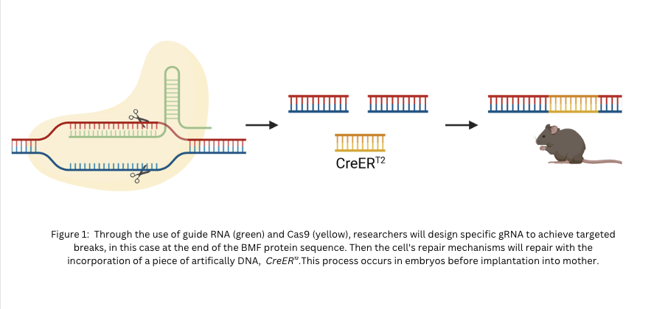
Figure 1

Figure 1: Through the use of guide RNA (green) and Cas9 (yellow), researchers will design specific gRNA to achieve targeted breaks, in this case at the end of the BMF protein sequence. Then the cell's repair mechanisms will repair with the incorporation of a piece of artificially DNA, CreER .This process occurs in embryos before implantation into the mother.
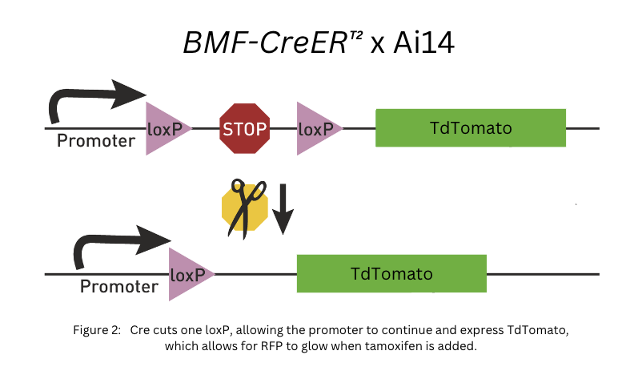
Figure 2

Figure 2: Through the use of guide RNA (green) and Cas9 (yellow), researchers will design specific gRNA to achieve targeted breaks, in this case at the end of the BMF protein sequence. Then the cell's repair mechanisms will repair with the incorporation of a piece of artificially DNA, CreER .This process occurs in embryos before implantation into the mother.

Science Fair Experiment
The cells chosen to test the validity of the mice line were retinal ganglion cells. The retina is the light-sensitive tissue at the back of the eye, crucial for vision. It consists of various cell types, including photoreceptors that detect light, and retinal ganglion cells (RGCs) responsible for transmitting visual information to the brain. RGC pruning is a crucial developmental process in the retina. It typically occurs during a specific phase of development, where excess or unnecessary connections between RGCs and their targets are eliminated to refine the neural circuitry. This process is essential for proper visual system function. In mice, the specific age group during which retinal ganglion cells (RGCs) undergo pruning is typically around the second and third weeks after birth. Because the retina is a very well-characterized pruning event, we know when it happens, what proteins are involved, etc. Therefore, if the BMF mouse is labeling the right cells at the right time in the retina, we know it is most likely labeling cells that are pruning.

Animal Number | Treatment Given | Treatment age
OIL1_1 | Oil | P2-4
OIL1_2 | Oil | P2-4
OIL1_3 | Oil | P2-4
TAM2_1 | Tamox | P2-4
TAM2_2 | Tamox | P2-4
TAM2_3 | Tamox | P2-4
TAM4_1 | Tamox | P2-4
TAM4_2 | Tamox | P2-4
TAM4_3 | Tamox | P2-4
TAM5_2 | Tamox | P2-4
TAM5_3 | Tamox | P2-4
#03B07_c | Tamox | P15-17
#03B07_b | Tamox | P15-17
#03B07_a | Tamox | P15-17
#03B06_c | Tamox | P15-17
#03B06_b | Tamox | P15-17
#03B06_a | Tamox | P15-17
#03B04_c | Tamox | P15-17
#03B04_b | Tamox | P15-17
#03B04_a | Tamox | P15-17
#03B08_lineB | Oil | P15-17
#03B09_lineB | Oil | P15-17
TAM _LINE B_#03A02_1 | Tamox | Adult
TAM _LINE B_#03A02_2 | Tamox | Adult
TAM_03A02_lineB_1 | Tamox | Adult

Figure 3

Figure 3: To ensure a comprehensive understanding of the treatment effects across different developmental stages, my study design incorporates three distinct age groups: early postnatal (P2-4), adolescent (P15-17), and adult mice.

This approach lets us examine in detail how the treatment affects important stages throughout their life that can be mirrored in humans eventually. The allocation of animals in each group has been carefully planned to maintain a balance between control and experimental conditions. For the control groups, animals are administered with Oil, serving as a baseline for comparison against the treatment groups. The experimental groups receive Tamoxifen (Tamox), allowing for a direct assessment of its effects. Specifically, I have allocated three animals each in the early postnatal and adolescent stages for both Oil and Tamox treatments. In the P2-4 and P15-17 stages, the group receiving Tamoxifen is expanded to six animals to capture a broader range of data at this critical developmental phase where pruning is known to occur. This balanced and strategic distribution of animals across different treatments and developmental stages is designed to yield reliable data, enhancing the validity of my findings. It also adheres to ethical guidelines by optimizing the number of animals used to acquire significant scientific data while minimizing unnecessary use.
Once retrieving tissue and cutting tissue into 15μm using a cryostat, immunohistochemistry was performed: drying slides, PBS washing, application of primary antibodies (Rabbit Anti DsRed and Guinea Pig Anti RBPMS), overnight incubation, secondary antibody application (Goat Anti Guinea Pig 488, Goat Anti Rabbit 540, and DAPI), PBS washing, and mounting with FluoroGel. The slides were sealed with black nail polish to maintain longevity. Before analysis of data could occur, I began observing and practicing how to use a confocal with my lab mentor, graduate student Teresa Ubina.

Middle School Lesson
In my lesson to middle schoolers, I aimed to simplify the concept of neural pruning and highlight the spectated causes for abnormal pruning. Through a presentation and worksheet, I explained the process and significance of neural pruning. Additionally, provided background on different parts of a neuron to understand which parts are typically pruned, and its significance. I included two interactive activities: 1) creating a neuron (including each part of one) with candy 2) modeling neural connections using rubber bands on a brain board. Stimulating their active recall and thinking from the presentation, I created scenarios that either signified a loss, a gain, or reorganization of neural connections based on what was taught in the presentation.

CHAPTER 3
FINDING AND DATA ANALYSIS

Recording and Analyzing Data
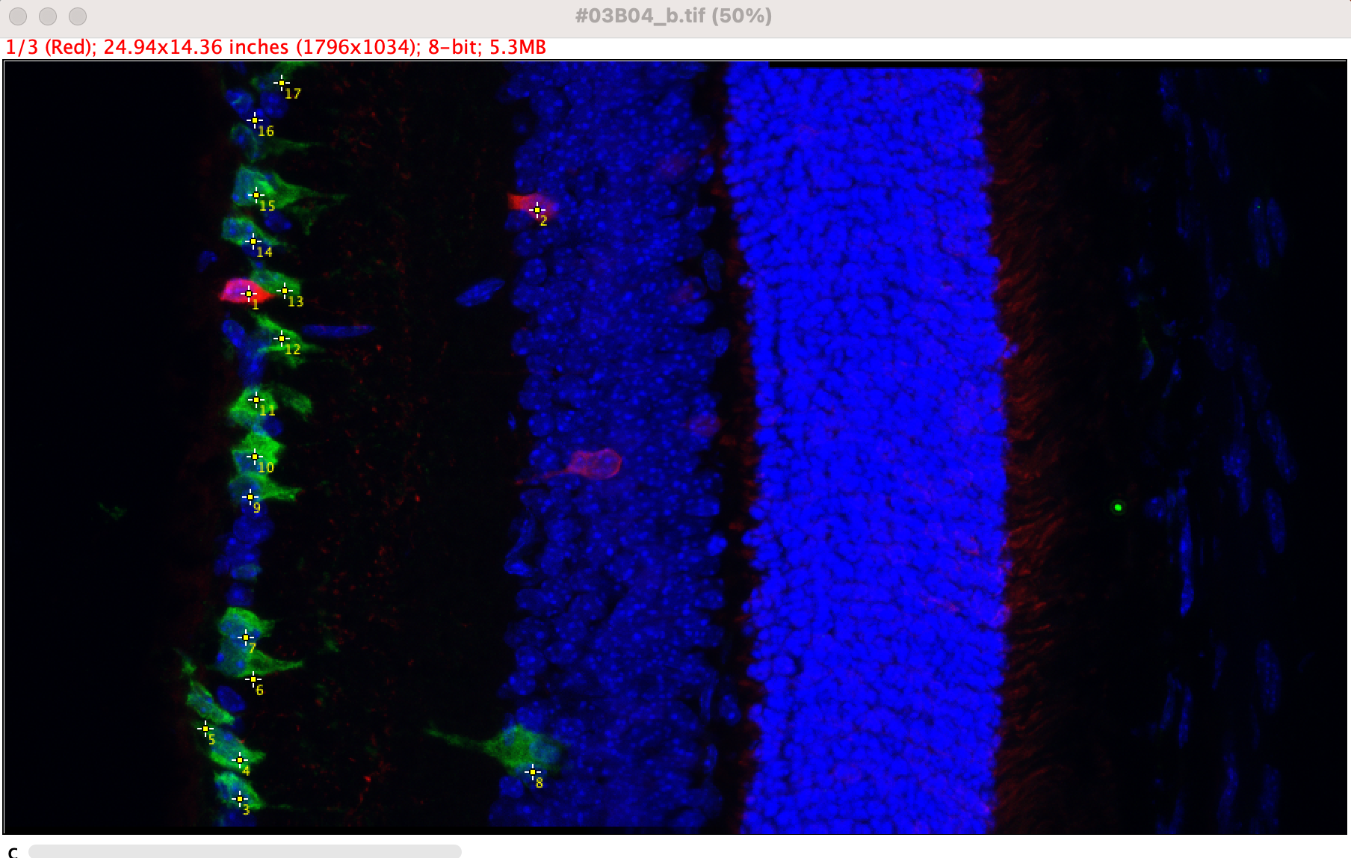
A confocal microscope, ImageJ, & Leica. Z-stack and Tile Scan to image DAPI cells (See Image 3), RBMf (Retinal ganglion - Green), and Tdt Tomato (Red).
Figure 4

Figure 4: Cell counting was conducted on each image file, quantifying and counting the amount of green and green and red cells.

File name | treatment | treatment age | # green cells | # red and green | %Positive (#red/#green)
OIL1_1 | Oil | P2-4 | 15 | 0 | 0.00
OIL1_2 | Oil | P2-4 | 12 | 0 | 0.00
OIL1_3 | Oil | P2-4 | 29 | 0 | 0.00
TAM2_1 | Tamox | P2-4 | 94 | 9 | 9.57
TAM2_2 | Tamox | P2-4 | 58 | 4 | 6.90
TAM2_3 | Tamox | P2-4 | 28 | 3 | 10.71
TAM4_1 | Tamox | P2-4 | 52 | 3 | 5.77
TAM4_2 | Tamox | P2-4 | 41 | 6 | 14.63
TAM4_3 | Tamox | P2-4 | 38 | 4 | 10.53
TAM5_2 | Tamox | P2-4 | 45 | 8 | 17.78
TAM5_3 | Tamox | P2-4 | 25 | 5 | 20.00
#03B07_c | Tamox | P15-17 | 19 | 0 | 0.00
#03B07_b | Tamox | P15-17 | 34 | 1 | 2.94
#03B07_a | Tamox | P15-17 | 35 | 0 | 0.00
#03B06_c | Tamox | P15-17 | 16 | 1 | 6.25
#03B06_b | Tamox | P15-17 | 20 | 0 | 0.00
#03B06_a | Tamox | P15-17 | 17 | 0 | 0.00
#03B04_c | Tamox | P15-17 | 20 | 0 | 0.00
#03B04_b | Tamox | P15-17 | 23 | 0 | 0.00
#03B04_a | Tamox | P15-17 | 24 | 1 | 4.17
#03B08_lineB | Oil | P15-17 | 19 | 0 | 0.00
#03B09_lineB | Oil | P15-17 | 14 | 0 | 0.00
TAM _LINE B_#03A02_1 | Tamox | Adult | 54 | 0 | 0.00
TAM _LINE B_#03A02_2 | Tamox | Adult | 30 | 0 | 0.00
TAM_03A02_lineB_1 | Tamox | Adult | 43 | 0 | 0.00
TAM_03A02_lineB_2 | Tamox | Adult | 35 | 0 | 0.00
TAM_03A02_lineB_3 | Tamox | Adult | 37 | 0 | 0.00

Figure 5

Figure 5: To organize all the files and data collected, I created a chart with info on each file and data collected including the number of retinal ganglion and retinal ganglion plus flagged TdTomato cells. This graph was then used to quantify data into a pivot table and bar graph. See Figure 6.

treatment | treatment age | AVERAGE of # red and green | STDEV of # red and green
Oil | P15-17 | 0 | 0
 | P2-4 | 0 | 0
Oil Total |  | 0 | 0
Tamox | Adult | 0 | 0
 | P15-17 | 0.3333333333 | 0.5
 | P2-4 | 5.25 | 2.251983253
Tamox Total |  | 2.045454545 | 2.819612819
Grand Total |  | 1.666666667 | 2.660248687

Figure 6

Figure 6: Separated and averaged out data to better draw conclusions between the control oil and tamoxifen fed mice, from the three different sample age groups. The pivot table points to affirmations that the tamoxifen treatment worked by aligning approximately with data of pruning in the eye of mice: 5.25 retinal ganglion x TdTomato cells aka pruned neurons.

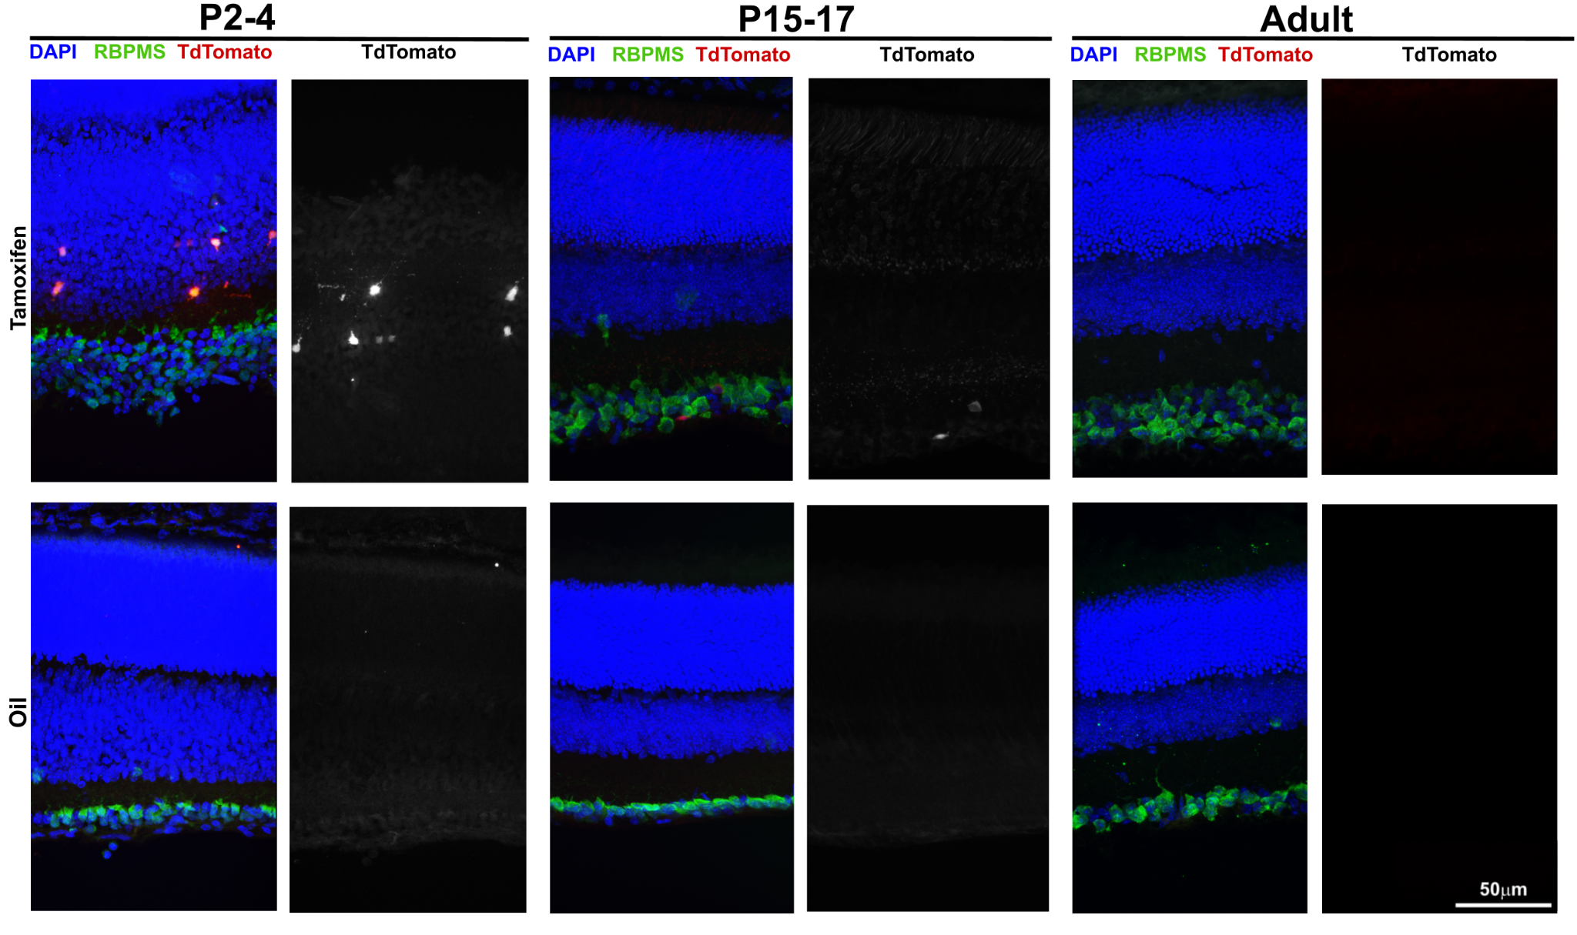
Figure 7

Once the data is analyzed, the best images from each time-fame were placed onto a table shown in Figure 7. A visual presentation including which lenses were placed to view DAPI, RBPMS, and tdTomato. Additionally, a comparison between control group oil and Tamoxifen for comparison. Lastly, a comparison in black and white for a clearer picture.

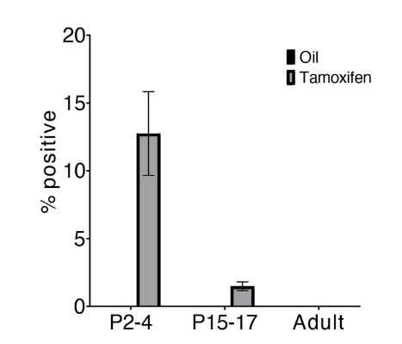
Figure 8

Figure 8: Quantified data into a bar graph based on % pruned cells with oil and tamoxifen. Results indicate an average count of 11.99% positive labeling at postnatal days 2-4. This aligns with the known pruning event and # of pruned in RGC. Additionally, between postnatal days 15-17 and adulthood, pruning decreases significantly, reaching 0%, affirming the mouse line's capability to label the correct pruning event occurring from age P2-4.

Overall Analysis
The positive labeling observed in the P2-4 age group, aligned with known pruning events, thus confirming the mouse line's efficacy in accurately capturing when pruning occured. Furthermore, the observed decrease in positive labeling from P15-17 to adulthood underscores the temporal specificity of the labeling process, reflecting the natural decline in pruning activity as development progresses. However, its number is slightly high and calls for potential signs of error. These findings collectively establish the Bmf-CreERT2 mouse line as a tool for investigating the molecular mechanisms underlying pruning events, offering significant insights into their implications for neurodevelopmental disorders.
CHAPTER 4
CONCLUSION

The objective of this project was to validate the reliability and effectiveness of a transgenic mouse line in accurately labeling neural pruning events within the brain. Initially, I hypothesized that the mouse line would successfully accomplish this task; however, data analysis revealed inconsistencies in its performance. Potential sources of error, such as prolonged tissue freezing and limited experience in immunohistochemistry, may have contributed to these discrepancies, making it challenging to detect the fluorescent protein and potentially overlooking labeled cells during analysis. Nonetheless, despite these challenges, the data demonstrated positive labeling in the P2-4 age group, consistent with established pruning events in retinal ganglion cells. Moreover, the observed decrease in positive labeling from P15-17 to adulthood underscored the precision of the labeling method, aligning with the anticipated decline in pruning activity as development progresses. Throughout this project, I have cultivated skills in observation, adaptability, and perseverance. Despite encountering setbacks, from complications in genotyping to convoluted in tissue slides, each obstacle served as a valuable learning opportunity. I embraced failure as a chance to refine my approach, meticulously documenting errors and persisting with determination. Looking ahead, I envision exploring new avenues utilizing the transgenic mouse line as a tool to identify unknown pruning events in various brain regions, including nasal epithelial cells. Investigating these uncharted territories during brain development holds promise in unraveling the chemical and molecular players of neurodevelopmental disorders. By delving into these unexplored regions, I aim to expand our understanding of brain development and potentially uncover novel insights into the pathophysiology of neurological conditions beyond schizophrenia and autism
As I transition to college, I eagerly anticipate delving into further laboratory projects centered around gene-editing technology. In my view, this innovative approach offers a promising avenue for addressing the biological challenges society faces today.

BIBLIOGRAPHY

References

Akhter, R., Saleem, S., Saha, A., & Biswas, S. C. (2018). The pro-apoptotic protein Bmf co-operates with Bim and Puma in neuron death induced by β-amyloid or NGF deprivation. Molecular and Cellular Neuroscience, 88, 249–257. https://doi.org/10.1016/j.mcn.2018.02.011

Austin Xun Ding, Sun, G., Argaw, Y. G., Wong, J., Sreesankar Easwaran, & Montell, D. J. (2016). CasExpress reveals widespread and diverse patterns of cell survival of caspase-3 activation during development in vivo. ELife, 5. https://doi.org/10.7554/elife.10936

Benjumeda, Isabel, et al. “Flowers and Weeds: Cell-Type Specific Pruning in the Developing Visual Thalamus.” BMC Biology, vol. 12, no. 1, 2014, p. 3, https://doi.org/10.1186/1741-7007-12-3.

Berlucchi, G., and H. A. Buchtel. “Neuronal Plasticity: Historical Roots and Evolution of Meaning.” Experimental Brain Research, vol. 192, no. 3, 12 Nov. 2008, pp. 307–319, https://doi.org/10.1007/s00221-008-1611-6.

Boksa, P. (2012). Abnormal synaptic pruning in schizophrenia: Urban myth or reality? The Journal of Psychiatry and Neuroscience, 37(2), 75–77. https://doi.org/10.1503/jpn.120007

Cherry, K., & Lakhan, S. (2022, November 8). How Brain Neurons Change Over Time From Life Experience. Verywell Mind. https://www.verywellmind.com/what-is-brain-plasticity-2794886#:~:text=This%20process%20is%20known%20as

Cusack, C. L., Swahari, V., Hampton Henley, W., Michael Ramsey, J., & Deshmukh, M. (2013). Distinct pathways mediate axon degeneration during apoptosis and axon-specific pruning. Nature Communications, 4(1). https://doi.org/10.1038/ncomms2910

Feinberg, I. (2017). Why is synaptic pruning important for the developing brain? Scientific American Mind, 28(3), 75–75. https://doi.org/10.1038/scientificamericanmind0517-75

Lewis, David A., and Pat Levitt. “Schizophrenia as a Disorder of Neurodevelopment.” Annual Review of Neuroscience, vol. 25, no. 1, Mar. 2002, pp. 409–432, https://doi.org/10.1146/annurev.neuro.25.112701.142754.

Murty, Vishnu, et al. “The Role of Experience in Adolescent Cognitive Development: Integration of Executive, Memory, and Mesolimbic Systems.” Neuroscience and Biobehavioral Reviews, vol. 70, 1 Nov. 2016, pp. 46–58, www.ncbi.nlm.nih.gov/pmc/articles/PMC5074888/, https://doi.org/10.1016/j.neubiorev.2016.07.034.

Nagappan, Palaniappan Ganesh, et al. “Neuroregeneration and Plasticity: A Review of the Physiological Mechanisms for Achieving Functional Recovery Postinjury.” Military Medical Research, vol. 7, no. 1, 15 June 2020, mmrjournal.biomedcentral.com/articles/10.1186/s40779-020-00259-3, https://doi.org/10.1186/s40779-020-00259-3.

Osimo, E. F., Beck, K., Reis Marques, T., & Howes, O. D. (2018). Synaptic loss in schizophrenia: a
meta-analysis and systematic review of synaptic protein and mRNA measures. Molecular Psychiatry, 24(4), 549–561. https://doi.org/10.1038/s41380-018-0041-5

Thomas, M. S. C., Davis, R., Karmiloff-Smith, A., Knowland, V. C. P., & Charman, T. (2015). The over-pruning hypothesis of autism. Developmental Science, 19(2), 284–305. https://doi.org/10.1111/desc.12303

UC David Center for Neuroscience. (2020, September 11). Making and breaking connections in the brain. UC Davis Center for Neuroscience. https://neuroscience.ucdavis.edu/news/making-and-breaking-connections-brain#:~:text=So%20one%20neuron%2C%20the%20transmitter

Voss, P., Thomas, M., Cisneros- Franco, J. Miguel., & de Villers-Sidani, É. (2017). Dynamic Brains and the Changing Rules of Neuroplasticity: Implications for Learning and Recovery. Frontiers, 8. https://www.frontiersin.org/journals/psychology/articles/10.3389/fpsyg.2017.01657/full

Sun, Tao, and Christopher A. Walsh. “Molecular Approaches to Brain Asymmetry and Handedness.” Nature Reviews Neuroscience, vol. 7, no. 8, 1 Aug. 2006, pp. 655–662, www.nature.com/articles/nrn1930, https://doi.org/10.1038/nrn1930.

ANNOTATED BIBLIOGRAPHY

References
Akhter, R., Saleem, S., Saha, A., & Biswas, S. C. (2018). The pro-apoptotic protein Bmf co-operates with Bim and Puma in neuron death induced by β-amyloid or NGF deprivation. Molecular and Cellular Neuroscience, 88, 249–257. https://doi.org/10.1016/j.mcn.2018.02.011
The article explores the role of the pro-apoptotic Bcl-2 homology 3 domain only
(BH3-only) protein, Bcl-2 modifying factor (Bmf), in neuron death induced by
beta-amyloid (Aβ) toxicity or NGF deprivation, both implicated in Alzheimer's
disease(AD). While BH3-only proteins like Bim and Puma are well-known
contributors to cell death, Bmf's involvement in neurodegeneration has been less
explored. Through experiments on neuron models, the study demonstrates that
Bmf, alongside Bim and Puma, plays a crucial role in Aβ-induced neuron death
and NGF deprivation. The results indicate that Bmf over-expression leads to cell
death, while Bmf knockdown protects neurons against Aβ or NGF
deprivation-induced death. Moreover, the study highlights Bmf's cooperation with
Bim and Puma, showing that the simultaneous knockdown of these proteins
enhances protection against Aβ toxicity. This research sheds light on the intricate
molecular mechanisms underlying neuron death in AD, emphasizing the
importance of BH3-only proteins like Bmf and their interactions in this
Pathological context.

Austin Xun Ding, Sun, G., Argaw, Y. G., Wong, J., Sreesankar Easwaran, & Montell, D. J. (2016). CasExpress reveals widespread and diverse patterns of cell survival of caspase-3 activation during development in vivo. ELife, 5. https://doi.org/10.7554/elife.10936
The article investigates the phenomenon of cell survival following caspase-3 activation in vivo, using a new method called CasExpress, which enables the tracking of cells that survive caspase-3 activation in Drosophila. While executioner caspases are traditionally associated with promoting apoptosis, this study aims to systematically document instances where cells survive caspase-3 activation. The experiments reveal widespread survival of caspase-3 activity across various tissues and developmental stages. Notably, some cells activate caspase-3 during normal development without undergoing apoptosis, indicating a novel role for caspase-3 unrelated to cell destruction. In other tissues, caspase-3 activation is sporadic and overlaps with periods of apoptosis. The findings suggest that cell survival following caspase-3 activation, termed anastasis, is more prevalent than previously thought. The study's innovative approach sheds light on the complexity of cell fate decisions and highlights the need for further exploration of the molecular mechanisms underlying caspase-3-mediated cell survival. This knowledge could potentially inform the development of therapies targeting cell survival or apoptosis in various physiological and pathological contexts, such as heart muscle regeneration or cancer treatment.

Boksa, P. (2012). Abnormal synaptic pruning in schizophrenia: Urban myth or reality? The Journal of Psychiatry and Neuroscience, 37(2), 75–77. https://doi.org/10.1503/jpn.120007
The article discusses the phenomenon of synaptic pruning in schizophrenia, focusing on its potential role in the onset and progression of the disorder. Synaptic pruning refers to the process of elimination of excess neuronal synapses, which is crucial for normal brain development. The author reviews early electron microscopy studies and recent molecular profiling studies that shed light on the timing and mechanisms of synaptic pruning during human brain development. Notably, alterations in synaptic density, dendritic spine density, and presynaptic protein markers have been observed in postmortem brains of adult schizophrenia patients, suggesting abnormalities in synaptic connectivity. Neuroimaging studies of patients with first-episode schizophrenia further support the idea of enhanced synaptic pruning during early stages of the disorder, coinciding with pronounced grey matter loss. Molecular mechanisms involving N-methyl-D-aspartate (NMDA) receptor activation, cytoskeletal dynamics, and neurotrophic factors are implicated in synaptic stabilization and pruning, providing potential targets for therapeutic intervention. However, the author emphasizes the need for further research to fully elucidate the role of abnormal synaptic pruning in schizophrenia and its implications for treatment.

Cherry, K., & Lakhan, S. (2022, November 8). How Brain Neurons Change Over Time From Life Experience. Verywell Mind. https://www.verywellmind.com/what-is-brain-plasticity-2794886#:~:text=This%20process%20is%20known%20as
Cherry offers a comprehensive overview of neuroplasticity, highlighting the brain's remarkable ability to reorganize itself throughout life. Contrary to earlier beliefs that neurogenesis ceases shortly after birth, contemporary understanding recognizes that the brain can form new connections, redistribute functions, and even create new neurons. The text explains the mechanisms of neuroplasticity, emphasizing synaptic pruning and the formation of new synapses based on experiences. It discusses the benefits of neuroplasticity, including its role in learning, cognitive enhancement, and recovery from injuries like strokes. Furthermore, practical strategies to enhance neuroplasticity are provided, such as enriching environments, prioritizing sleep, regular exercise, practicing mindfulness, and engaging in playful activities. The source also acknowledges limitations to brain plasticity, particularly in cases of irreparable damage to specific brain areas. Lastly, it traces the evolution of understanding regarding neuroplasticity from early beliefs in the brain's fixed nature to modern discoveries demonstrating its adaptability and capacity for change, emphasizing the importance of ongoing challenges, adequate rest, and healthy habits in promoting and maintaining brain plasticity throughout life.

Cusack, C. L., Swahari, V., Hampton Henley, W., Michael Ramsey, J., & Deshmukh, M. (2013). Distinct pathways mediate axon degeneration during apoptosis and axon-specific pruning. Nature Communications, 4(1). https://doi.org/10.1038/ncomms2910
Neurons have two ways to deal with cell damage: apoptosis (cell destruction) and axon degeneration (pruning). Both processes involve proteins like Bax and caspases. Research shows that axon degeneration during apoptosis is different from axon pruning.Caspase-6 activates in axons when there's a lack of nerve growth factor, but it only protects axons in specific situations, not during whole-cell apoptosis. Axon-selective degeneration requires Caspase-9 and Caspase-3, which are not needed for apoptosis. Mechanisms like proteasome activity and the X-linked inhibitor of apoptosis protein protect cell bodies of degenerating axons from caspase activation. Mature neurons can prevent apoptosis while still allowing axon degeneration, showing independent regulation. These findings reveal how neurons control both apoptosis and axon-selective degeneration to adapt without risking neurodegeneration.

Feinberg, I. (2017). Why is synaptic pruning important for the developing brain? Scientific American Mind, 28(3), 75–75. https://doi.org/10.1038/scientificamericanmind0517-75
The article delves into the intricate process of synaptic pruning, a pivotal mechanism in nervous system development aimed at refining neural connections. It challenges the misconception that unsuccessful neurons are inherently flawed, clarifying that many fail to establish connections with their predetermined targets. Significant contributions by researchers, notably the late Peter Huttenlocher, have shed light on synaptic pruning's extended timeline, revealing that it continues long after birth. Through meticulous electron microscopy studies on human brains, Huttenlocher demonstrated that synapses, the connections between neurons, proliferate postnatally, reaching peak levels during childhood before sharply declining in adolescence. This dynamic process of synapse formation and elimination shapes neural circuits, potentially underpinning the cognitive enhancements observed during late adolescence and early adulthood. Furthermore, synaptic pruning's implications extend beyond normal brain development, as aberrations in this process have been implicated in various neuropsychiatric disorders. Notably, the hypothesis proposed by the author in 1982, suggesting a link between disordered synaptic pruning and the onset of schizophrenia, has gained support from recent genetic and experimental findings published in prestigious scientific journals. Thus, while synaptic pruning holds profound implications for understanding brain function and development, its dysregulation may contribute to the pathophysiology of debilitating mental illnesses, emphasizing the urgency of further research in this field.

Osimo, E. F., Beck, K., Reis Marques, T., & Howes, O. D. (2018). Synaptic loss in schizophrenia: a meta-analysis and systematic review of synaptic protein and mRNA measures. Molecular Psychiatry, 24(4), 549–561. https://doi.org/10.1038/s41380-018-0041-5
​​This study examines changes in certain proteins and their levels in the brains of people with schizophrenia. It focuses on proteins involved in the communication between brain cells. The study finds lower levels of a protein called synaptophysin in specific brain areas of those with schizophrenia, suggesting a loss of connections between cells in these regions. Other proteins like SNAP-25, PSD-95, and VAMP, which are also important for cell communication, didn't show significant changes in some brain areas. However, there were fewer studies on other proteins, making it harder to conclude them. Overall, the findings support the idea that schizophrenia involves a loss of these cell connections, but there may be differences depending on the brain region and protein involved.

Thomas, M. S. C., Davis, R., Karmiloff-Smith, A., Knowland, V. C. P., & Charman, T. (2015). The over-pruning hypothesis of autism. Developmental Science, 19(2), 284–305. https://doi.org/10.1111/desc.12303
This article discusses the over-pruning hypothesis of autism, which suggests that there's excessive trimming of brain connections during early development. This hypothesis, originally proposed in a neurocomputational model, is now expanded to explain different timing of autism symptoms, like early or late onset, or regression. It's suggested that siblings of those with autism might inherit a milder version of this problem or risk factors without the actual mechanism. This over-pruning theory predicts that early signs of autism might be sensory or motor issues rather than social ones, which is supported by some studies. The article reviews the evidence for and against this hypothesis, comparing it to other theories and discussing its implications for understanding autism and its potential causes.

UC David Center for Neuroscience. (2020, September 11). Making and breaking connections in the brain. UC Davis Center for Neuroscience. https://neuroscience.ucdavis.edu/news/making-and-breaking-connections-brain#:~:text=So%20one%20neuron%2C%20the%20transmitter
In her article "Making and breaking connections in the brain," Kimberley McAllister, Director of the Center for Neuroscience at the University of California, Davis, navigates the intricate terrain of synaptic function and development. With a keen focus on the pivotal role of synapses in facilitating neural communication, McAllister elucidates how these connections underpin fundamental cognitive processes essential for learning and adaptation. Through a meticulous exploration of synaptic formation during brain development, she unveils the intricate interplay between neural activity and synapse refinement, highlighting the critical influence of environmental stimuli on shaping neural circuits. Furthermore, McAllister delves into the implications of synaptic aberrations for neurodevelopmental disorders like autism and schizophrenia, emphasizing the imperative of understanding synaptic pathology in elucidating the etiology of these conditions. Additionally, she examines recent advancements in neuroscience, particularly the burgeoning research on the involvement of immune cells and molecules in brain development. By unraveling the intricate interplay between immune-mediated mechanisms and synaptic plasticity, McAllister offers profound insights into the potential links between immune responses and neurological disorders, paving the way for innovative therapeutic interventions to ameliorate synaptic dysfunction and enhance brain health.

Voss, P., Thomas, M., Cisneros- Franco, J. Miguel., & de Villers-Sidani, É. (2017). Dynamic Brains and the Changing Rules of Neuroplasticity: Implications for Learning and Recovery. Frontiers, 8. https://www.frontiersin.org/journals/psychology/articles/10.3389/fpsyg.2017.01657/full
The summarized article was written by Patrice Voss and published in a research journal by Frontiers. Voss's article explores the dynamic nature of neuroplasticity in the brain, challenging the traditional notion that it is primarily limited to early developmental stages. Voss provides evidence suggesting that mechanisms of neuroplasticity are highly variable across individuals and throughout the lifespan, influenced by factors such as inhibitory network function, neuromodulator systems, age, sex, brain disease, and psychological traits. They discuss how sensory experiences shape cortical plasticity during critical periods (CPs), emphasizing that CPs can also be reopened later in life due to various factors. Voss highlights the role of plasticity inhibitors and molecular brakes in stabilizing sensory representations, pointing to their modulation as a potential avenue for enhancing plasticity in the adult brain. Additionally, they examine how sensory inputs with low signal-to-noise ratios can trigger plasticity in the mature cortex and discuss the role of neuromodulator systems in driving plasticity. Moreover, Voss delves into the inter-individual variability of neuromodulator tone and its impact on brain plasticity and cognition, emphasizing the need for personalized treatment approaches. They also discuss how neuropathological conditions and drug treatments can alter neuromodulator balance, affecting brain plasticity and sensory processes. Voss concludes by advocating for personalized neurotherapeutic interventions targeting mechanisms of plasticity and cognition to maximize learning, memory, and recovery from brain injury or disease.

Part III: Research Plan

Rationale:
During neuronal development, an overproduction of synaptic connections is a typical phenomenon. For the brain to establish appropriate neural circuitry, a substantial number of these surplus connections must undergo a process termed synaptic pruning. Emerging research points out that the pruning process may play a role in the onset of schizophrenia during the adolescent and early adult years. This theory is corroborated by evidence indicating that individuals afflicted with schizophrenia frequently exhibit reduced cortical thickness, a manifestation indicative of synaptic diminution (Osimo, 2018).
Additionally, synaptic development and stabilization are significantly influenced by certain genes, several of which are associated with autism. Some of these genes include gamma‐aminobutyric acid (GABA) and N‐methyl‐D‐aspartate (NMDA) receptors (Keshavan, 20). These are important for building and maintaining synaptic networks. Disruptions in these genetic pathways can lead to dysregulation in synaptic connectivity, one manifestation of which is an overabundance of synaptic connections leading to autism.
In normal brain development, a burst of synapse formation occurs in infancy, specifically in the cortex, a region involved in autistic behaviors. About half of these cortical synapses by late adolescence should be pruned (Akhter, 2018) in normal brains.
- How people label pruning events currently:
  - One of the ways is by manually counting cells at different ages in specific areas of the brain.
  - Caspase activation:
    - Caspases normally exist in cells in an inactive state so it is hard to track when they become active. And evidence that they were active is not around for very long so it is hard to know which cells activated it and when.
  - There is a tool in fruit flies (CasExpress) that can track caspase activation, but no mammalian equivalent exists.
  - Currently, tools that can track pruning can only detect these events for a short window of time, making it difficult to track and study cells that have previously undergone pruning.
- Why we chose to study eye cells:
- Background on the Retina:
  - The retina is the light-sensitive tissue at the back of the eye, crucial for vision. It consists of various cell types, including photoreceptors that detect light, and retinal ganglion cells (RGCs) responsible for transmitting visual information to the brain.
- When do RGCs Prune:
  - RGC pruning is a crucial developmental process in the retina. It typically occurs during a specific phase of development, where excess or unnecessary connections between RGCs and their targets are eliminated to refine the neural circuitry. This process is essential for proper visual system function.
    - In mice, the specific age group during which retinal ganglion cells (RGCs) undergo pruning is typically around the second and third weeks after birth.
    - The retina is a very well-characterized pruning event. We know when it happens, what proteins are involved, etc. Therefore, if the BMF mouse is labeling the right cells at the right time in the retina, we know it is most likely labeling cells that are pruning.
- How is the BMF mice line able to label pruning events?
  - The mice were created using CRISPR to knock in CreER^{T2} at the end of the coding sequence for the Bmf gene. This means that whenever BMF is being expressed, so will CreER^{T2}.
  - Cre recombinase enzyme recognizes and acts on specific DNA sequences known as LoxP sites.
    - LoxP sites are short, specific DNA sequences that serve as recognition sites for Cre recombinase.
  - When a gene of interest is flanked by two LoxP sites, Cre recombinase can excise the intervening DNA segment, leading to the deletion or alteration of the targeted gene.
  - This system allows researchers to conditionally activate or inactivate genes in specific tissues, at particular developmental stages, or under defined conditions.
  - In this transgenic mouse line, the enzyme Cre recombinase functions on specific DNA sequences known as loxP sites. Upon exposure to a substance called tamoxifen, Cre binds with CreER^{T2}, facilitating its entry into the cell nucleus. Once inside, it activates the expression of the fluorescent protein tdTomato. The strategic use of tamoxifen provides us with the ability to regulate when Cre is active. This level of control is instrumental in labeling and mapping cells and tissues, allowing for precise and temporally controlled genetic modifications.
  - Bmf was chosen since it is an upstream activator of EC signaling in both pruning and apoptosis that is expressed in a greater manner during caspase-dependent refinement. Preliminary data shows that in the mouse retina Bmf, a known regulator of caspase activity, is upregulated approximately 100-fold just prior to RGC pruning.

Vertebrate Animal Research:
- Discuss for use of vertebrate animals and justification
  - In conducting this research, the utilization of vertebrate animals, specifically engineered mouse lines, was imperative due to the specific nature of the investigation. My primary objective was to examine whether these genetically modified mice could effectively demonstrate and label neural pruning events. This approach is vital as current alternative methods do not sufficiently replicate the complex neural processes involved in pruning.
The justification for the use of vertebrate animals, in this case, is grounded in the necessity to closely mimic the neural development and pruning processes in a controlled environment, something that is currently unachievable with in vitro or computational models. The complexity of neural pruning, particularly its intricate biological and chemical processes, requires a living model to provide accurate and relevant data.
The potential impact of this research is significant. By using these engineered mouse lines, I aim to establish a model that can be utilized in future projects to better understand the mechanisms of neural pruning. This is especially relevant in the context of neurodevelopmental disorders such as autism and schizophrenia. A deeper understanding of the pruning process in these conditions could lead to breakthroughs in both diagnosis and treatment.
Furthermore, the development of a reliable animal model for neural pruning could pave the way for more advanced research into other neurological conditions, potentially leading to a broader understanding of the human brain and its development. This research, therefore, not only contributes to the field of neurodevelopmental disorders but also expands our overall knowledge of neural biology.
- Detail all procedures using Vertebral Animals
  - During my experiment, I did not handle live animals, it was all fixed tissue, therefore no vertebral animals experienced any risks or potential discomforts
- Animal Information
  - Mice species: Mus musculus; Sex: Unknown/not recorded
Animal Number | Treatment Given | Treatment age
OIL1_1 | Oil | P2-4
OIL1_2 | Oil | P2-4
OIL1_3 | Oil | P2-4
TAM2_1 | Tamox | P2-4
TAM2_2 | Tamox | P2-4
TAM2_3 | Tamox | P2-4
TAM4_1 | Tamox | P2-4
TAM4_2 | Tamox | P2-4
TAM4_3 | Tamox | P2-4
TAM5_2 | Tamox | P2-4
TAM5_3 | Tamox | P2-4
#03B07_c | Tamox | P15-17
#03B07_b | Tamox | P15-17
#03B07_a | Tamox | P15-17
#03B06_c | Tamox | P15-17
#03B06_b | Tamox | P15-17
#03B06_a | Tamox | P15-17
#03B04_c | Tamox | P15-17
#03B04_b | Tamox | P15-17
#03B04_a | Tamox | P15-17
#03B08_lineB | Oil | P15-17
#03B09_lineB | Oil | P15-17
TAM _LINE B_#03A02_1 | Tamox | Adult
TAM _LINE B_#03A02_2 | Tamox | Adult
TAM_03A02_lineB_1 | Tamox | Adult
TAM_03A02_lineB_2 | Tamox | Adult

To ensure a comprehensive understanding of the treatment effects across different developmental stages, my study design incorporates three distinct age groups: early postnatal (P2-4), adolescent (P15-17), and adult mice. This approach lets us examine in detail how the treatment affects important stages throughout their life that can be mirrored in humans eventually.
The allocation of animals in each group has been carefully planned to maintain a balance between control and experimental conditions. For the control groups, animals are administered with Oil, serving as a baseline for comparison against the treatment groups. The experimental groups receive Tamoxifen (Tamox), allowing for a direct assessment of its effects.
Specifically, I have allocated three animals each in the early postnatal and adolescent stages for both Oil and Tamox treatments. In the P2-4 and P15-17 stages, the group receiving Tamoxifen is expanded to six animals to capture a broader range of data at this critical developmental phase where pruning is known to occur.
This balanced and strategic distribution of animals across different treatments and developmental stages is designed to yield reliable data, enhancing the validity of my findings. It also adheres to ethical guidelines by optimizing the number of animals used to acquire significant scientific data while minimizing unnecessary use.
- Disposition of the animals at the end of the study
  - After the study, the prepared slides were returned to cold storage. This ensures their viability for future research endeavors, allowing for their continued contribution to scientific advancement in subsequent projects

Research Question: What neurodevelopmental disorders are associated with pruning in adolescents can the BMF mice line be utilized to investigate such anomalies?
Hypothesis: The BMF mice line can be effectively utilized to investigate anomalies in neural pruning associated with neurodevelopmental disorders in adolescents, providing valuable insights into the underlying mechanisms and potential therapeutic targets.
- By observing and analyzing the neural pruning patterns in BMF mice, researchers can potentially uncover specific irregularities and genetic factors that contribute to these disorders, thereby aiding in the development of more effective treatments and interventions.
Engineering Goal:
- The primary goal is to engineer a genetically modified mouse line, Bmf-CreER^{T2}, that can effectively label neural pruning events. This is achieved by crossing the Bmf-CreER^{T2} mice with the Cre reporter line, Ai14, leading to the expression of a red fluorescent protein (tdTomato) in cells where Bmf is active. This would allow for the development of a reliable model that allows for the visualization and study of the molecular mechanisms underlying neural pruning, particularly to conditions such as schizophrenia and autism.

Expected Outcome:
- The expected outcome of this engineering effort is the validation of the Bmf-CreER^{T2} mouse line as a tool for identifying and studying pruning events. This is demonstrated by the ability of the mouse line to show clear, age-specific labeling of pruning events, particularly during key developmental stages (P-2-4).
- Positive results, such as the observed average count of 11.99% positive labeling at postnatal days 2-4, confirm the mouse line's effectiveness in accurately labeling the targeted cells during known pruning events. To strengthen its validity, I should be able to see a significant decrease in labeling between postnatal days 15-17 and adulthood would further affirm the model's specificity and utility. Ultimately, the successful establishment of this mouse line would enable its application in broader research contexts, potentially leading to the discovery of unknown pruning events and enhancing our understanding of various neurodevelopmental disorders.

Materials:
- Phosphate buffered saline (PBS)
- Retinal tissue sectioned at 15um thickness
- Bovine serum albumin (BSA)
- Triton-X100
- Rabbit anti DsRed antibody
- Guinea Pig anti RBPMS antibody
- DAPI
- Humidifying chamber
- FluoroGel
- Coverslips
- Nail polish
- Confocal microscope
- Immersion oil
- ImageJ (Free software)
Procedures:
- IHC Steps Antibody for Cryosections:
Day 1:
  - Let slide sit for 10 min to dry when taken out of -80°C freezer
  - Wash slide with PBS for 15’ or until OCT haze is removed.
    - Careful not to have tissue slide off
    - Place into humidifying chamber
  - Using the hydrophobic pen fill in area surrounding tissue on the slide
    - Making sure not to touch the tissue itself.
  - Create antibody 1 buffer: 2 mL 3% BSA + 6 μL TritonX, mix using vortex until homogeneous
  - Add 4 μL Rabbit Anti DsRed + 4μL Guinea pig AntiRBPms (a 1/500 dilution) into antibody buffer
  - Put onto slide until tissue is covered by layer of solution
  - Close lit, place into freezer overnight
Day 2:
- Wash w/ PBS 3x10min each
- Create Secondary Antibody Buffer: 2μL of TritonX + 2 mL 3% BSA. Spin in vortex
- Add 4μL of Goat Anti Guinea Pig 488 + 4 μL Goat Anti Rabbit 540 + 10 μL Dapi into secondary antibody buffer
- Place into a humidifying chamber. Put the 2nd buffer onto slides after washes are finished. Enough to cover entire tissue
- Wait 1 hr.
- After, wash PBS 3x10min
2. Mount slides
- Add fluorogel
- Place cover-slip and let excess fluorogel drip off and then dry
- Paint all 4 sides with black nail polish let dry
3. Put oil onto slide, place onto confocal
4. Analyze slides using program ImageJ - Leica
- Settings: 405, 488, 532, 635
- Set format 524x524
- OPTIONAL if tissue is not in full view: Tile scan in order to get entire section of tissue (from RGC cells to membrane)
- Set Z-stack on Seq. 1 (DAPI cells), by turning the Z position dial all the way to the left until tissue is not visible. Do the same to the right. After change to Seq 2(RBMf -retinal ganglion - Green) and then Seq 3 (Tdt Tomato; labeled by BMF red), making sure tissue isn’t visible for either of the other two. (If you were to tile scan check each of the parts to make sure tissue isn’t seen)
- In process: project the image
- Label file under which age group, OIL or Tamoxifen, and what # picture
5. Count the amount of labeled green cells
6. Count the amount of green and red cells

